# 

# PlaqueQuant – Blood Vessel Stenosis Quantification Software User Manual Version 2.0 FOR BETA VERSION ONLY

**Table of Contents**

1 Introduction 3

1.1 Purpose 3

1.2 Highlighted Features 3

2 Installation 4

3 Usage 5

3.1 Workflow pipeline 5

3.2 Overall 6

3.3 Image Loading and Registration 10

3.4 Image Viewers 12

3.5 Image Examining 14

3.6 Segmentation 15

3.7 2D & 3D Numerical Measurements 22

3.8 Generate Report 27

3.9 Saving & Opening Segmentation 28

4 Known Issues 29

5 Update Log 29

## Introduction

### Purpose

PlaqueQuant is a software with various algorithms, which facilitates user to perform accurate segmentation of blood vessels. Quantitative analysis is performed to help user to quantify blood vessel stenosis

### Highlighted Features

The PlaqueQuant highlights the following features:

1. All-in-one pipeline system architecture.
2. Easy-to-use and intuitive interface.
3. DICOM image data well compatible.
4. Smart automatic segmentation algorithm.
5. 2D and 3D numerical analysis.
6. Automatic clinical report generator.

## Installation

Follow the instruction to install the software:

1. Unpack the zip/rar file.
2. Double click the installer file “Setup”.
3. Press “Install” when prompted with installation of Microsoft Visual C++ redistributable. Finish the rest of the installation as instructed.
4. Press “Run” when prompted with system security message.
5. Click “Finish” to finish installation.

## Usage

### Workflow pipeline

The PlaqueQuant adopt a pipeline fashion for each case as shown in **Error! Reference source not found.**.

Figure Workflow Diagram

### Overall

The following figure is the overall design of the software.

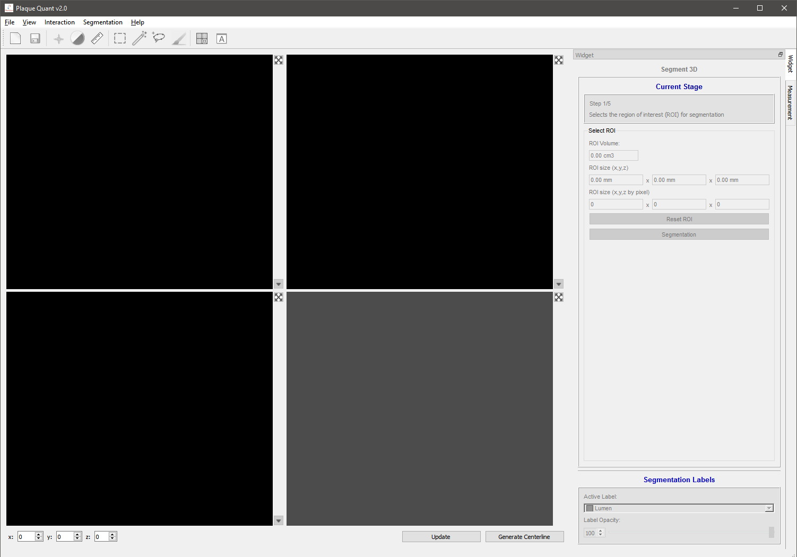

Figure Main Viewer

#### Basic Controls

In the tool bar, the software consists of 3 examining modes, 3 editing modes, 2 view models and the 2 basic function (open and save) for 2D viewers.

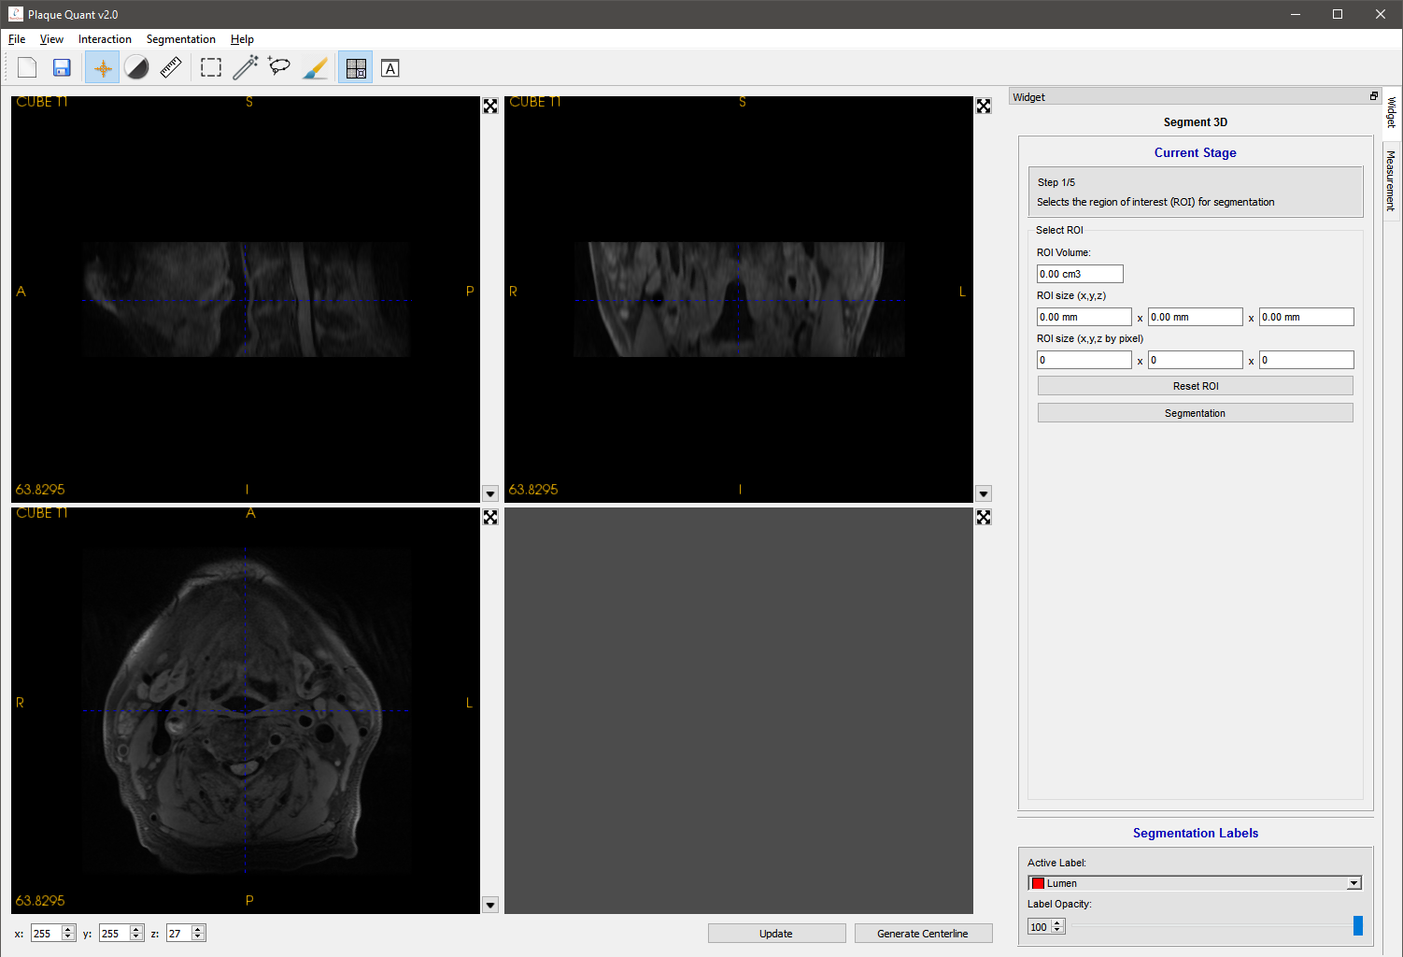

Figure Toolbar tooltips 1

|  |  |  |
| --- | --- | --- |
| **Functions** | | **Operations** |
| Open | * Open the registration wizard for loading images | |
| Save | * Open the saving wizard for saving the segmentation image | |

|  |  |
| --- | --- |
| **Modes** | **Operations** |
| All | * Move middle wheel to change slice |
| Navigation | * Left click to select slices location * Hold right click to zoom * Hold middle click to move camera |
| Level & width | * Hold left click to control the window level and widow width of images. |
| Distance | * Left click to place a point and measure the distance between 2 points |
| ROI | * Left click to the blue sphere and drag it, 3 ROI frames will move synchronously * All voxels in the extent of 3 frames will be extracted for doing segmentation |
| Contour | * Left click to place a contour point * Hold left click to keep placing contour points * Right click to extract lumen wall (when auto lumen segmentation enabled) * Double left clicks to draw the contour with specified label |
| Paint brush | * Hold left click to draw with specified label. * Hold right click to erase label as an eraser |

|  |  |
| --- | --- |
| **Views** | **Operations** |
| Multi-planar view of one modality | * Display 3 different views (axial view, sagittal view, coronal view) in 3 viewers which are from the same MRI modality image. |
| Axial view of multi-modality | * Display 3 views in 3 viewers of 3 different MRI modalities images all in axial view |

#### Viewer

There are 4 viewers in total. The lower right one is the 3D viewer; others are 2D viewers.

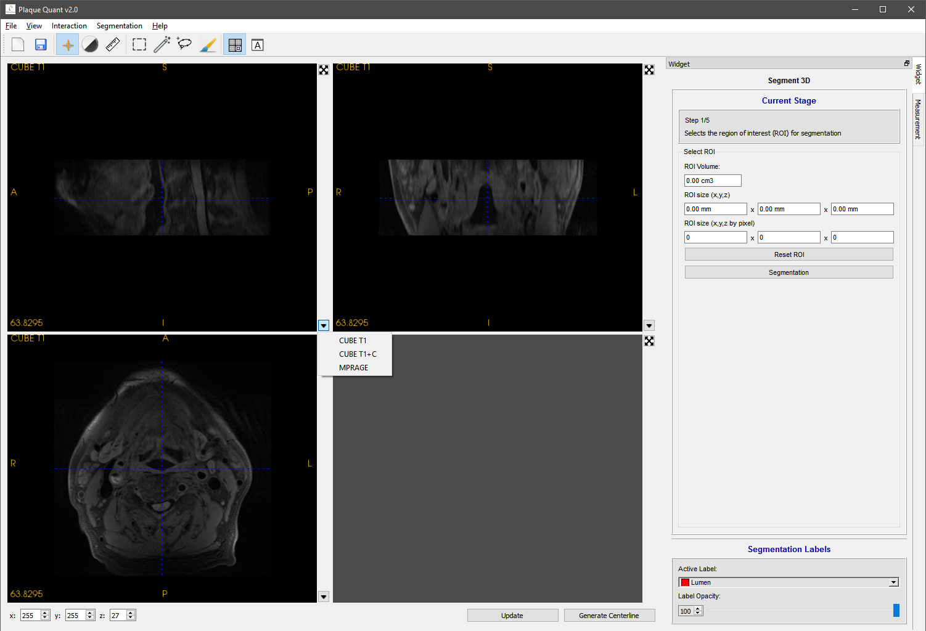

Figure Image viewers

As show in Figure 4, every 2D viewer has a capital letter to represent its directions following the doctor’s convention:

* S: superior
* I: interior
* A: anterior
* P: posterior
* R: right
* L: left

With reference to Figure 4:

* Upper left text shows the modality name.
* Lower left text shows the voxel intensity of the cursor.
* Upper right corner is a button which can toggle maximization of the current viewer.
* Lower right is a button “▼” for selecting modality.

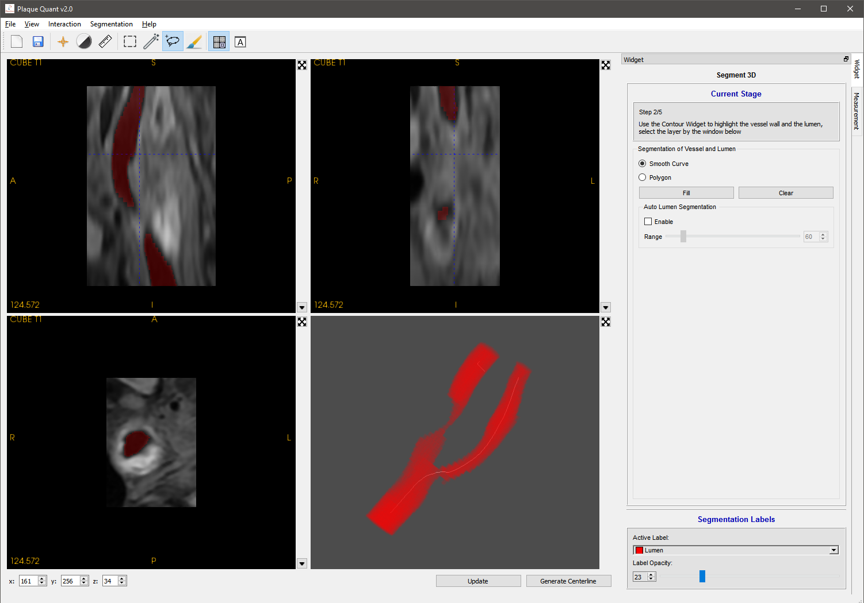

Figure 3D Viewer

3D viewer (Figure 5) visualize the segmentation within a customized ROI. Users can click on the button “Update” to render the segmented label. The button “Generate Centerline” will be explained in later sections.

|  |  |
| --- | --- |
| **Action** | **Description** |
| Holding left click | Rotation |
| Moving wheel and holding right click | Zoom-in and zoom-out |
| Holding middle button | Translating |
| Keyboard “r” | Resetting position |

### Image Loading and Registration

Medical image loading can be performed by clicking “File” -> “Open Image” OR “Recent Image” in menu bar. Then the “File loader” will pop up. The software is able to load multi-modality MRI image in DICOM or NIFTI format. Other formats are still not yet supported. By clicking “Open Image”, user is supposed to select accurate folder which contains images to be loaded. By clicking “Recent Image”, user can select the recent folder in history.

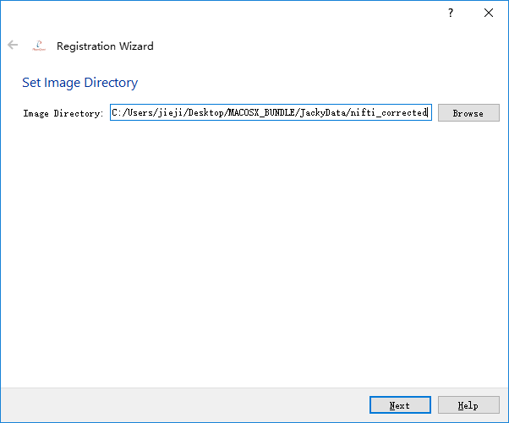

Figure File loader

In the next, all supported image data are loaded into the upper table, user should follow hints of the wizard and select relevant images. By clicking “<<” the highlighted image will insert to the corresponding slot. While clicking “X”, the image in the corresponding slot will be removed. The software is capable to load 5 different modalities MRI image (CUBE T1 image，CUBE T2 image，CUBE T1 + Contrast, 2D Double Inversion Recovery(DIR)/Quadruple inversion recovery(QIR), MPRAGE).

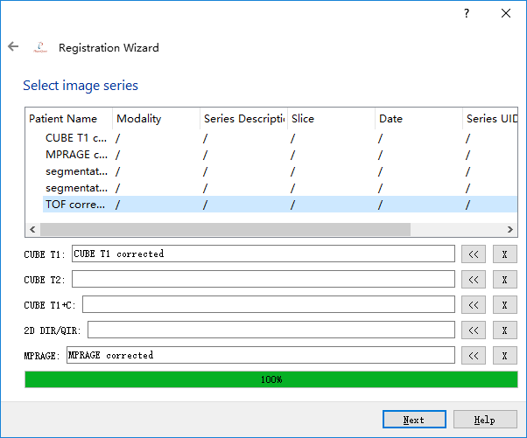

Figure Image selection

In the next, properties of the selected images are displayed and user can do the final confirm whether they are the correct image to be loaded (Only for DICOM, NIFTI do not have these properties). If not, user is capable to click the “<-” in the upper left to return previous wizards. If nothing goes wrong, user can click the “finish” and the software begins to load image and do the registration, which should be taken a few seconds. Please don’t be panic if the software is not responding.

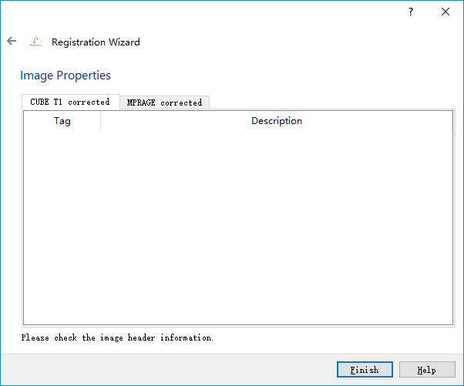

Figure Function tab options - Image Preprocessing

### Image Viewers

As it has already been written in 3.1, Multi-planar view of one modality and Axial view of multi-modality are 2 views for user to browse their images.

#### Multi-planar view of one modality

This is the default view mode. Pressing the  icon switch the view mode to multi-planar mode, which display the sagittal, coronal and axial view of the image. This mode restricts users to use the same modality.

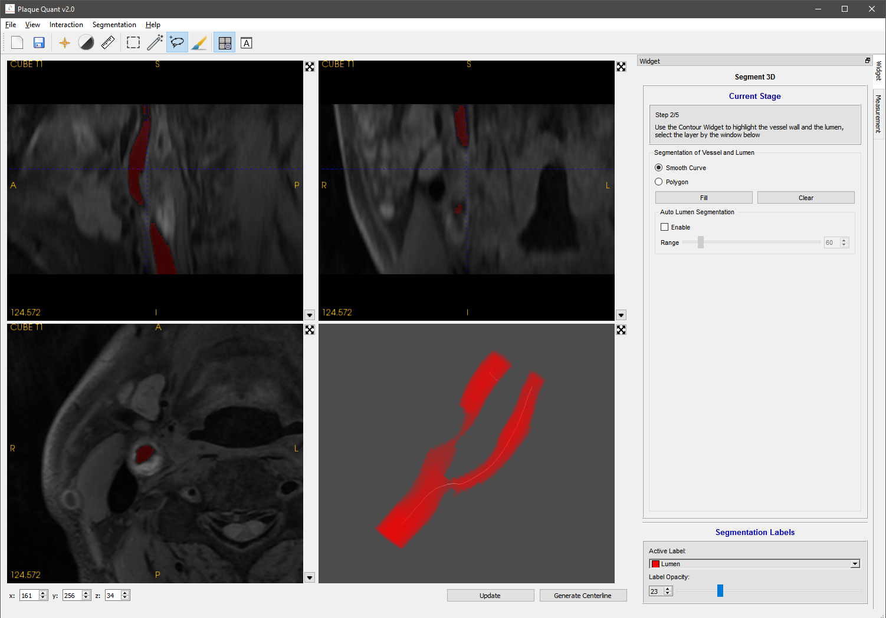

Figure Multi-planar view

#### Axial view of multi-modality

Pressing the  button switch the view mode to axial view. This mode allows user to simultaneously view images of different modality. The cursors (dotted-blue cross) of different views are yolked to the same voxel location. Users can perform segmentation with different modality with ease.

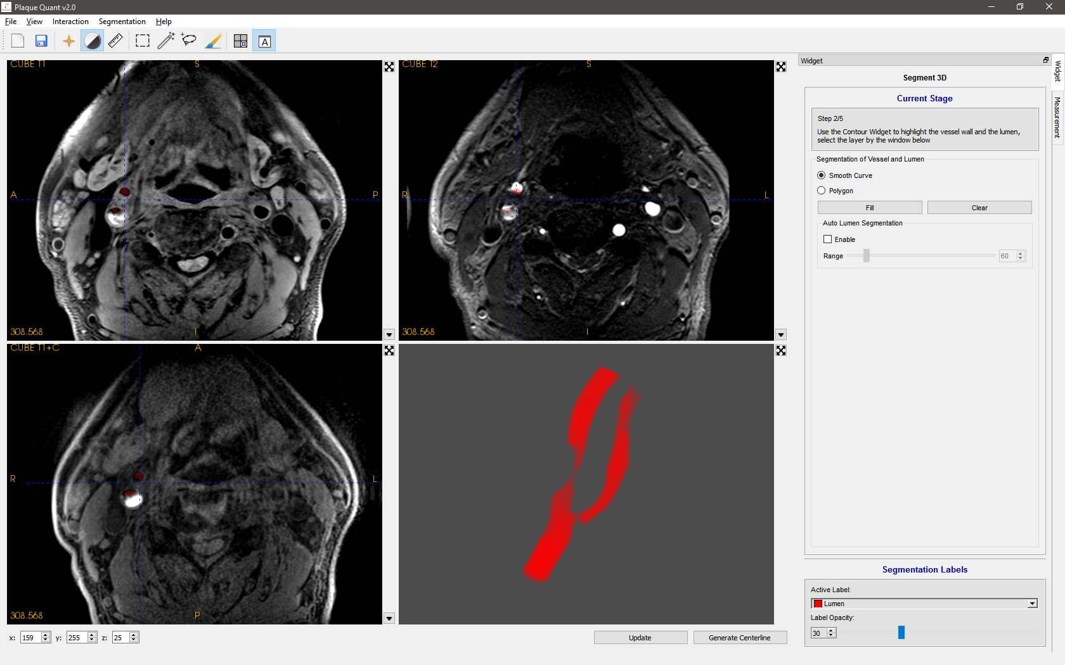

Figure Axial View

### Image Examining

As it has already been written in 3.1, Navigation mode, level & width mode and distance mode are 3 modes for user to examine their images.

#### Navigation

Holding left click: drag the blue cursor and the intensity in the lower left will update synchronously.

Middle button: drag the image position.

Holding right click: up to zoom-in, down to zoom-out.

Keyboard “r”: reset the image position.

#### Level & Width

Holding left click: change the 2D viewer’s window level and window width. While moving vertically, the window level will change. While moving horizontally, the window width will change.

#### Distance Measurement

The first left clicks: place a begin point of the distance widget.

The second left click: place an end point of the distance widget.

Both points have been placed: left click to drag one of those point to alter points’ positions.

### Segmentation

This program provides both manual and semi-automatic segmentation functionalities. There are two modes of manual segmentation, namely “Paint Brush” and “Contour Draw”, and two modes of semi-automatic segmentation, namely “Auto Lumen Extraction” and “Smart Contour”.

#### ROI(Optional)

Pressing the button  allow users to switch to ROI selecting mode. In this mode, user is supposed to select their region of interesting for segmentation. Selecting ROI will speed up calculations and is critical to automatic calculation of centerline. Users should adjust the ROI so that the inlet and the outlet of the interested branch are cut by the top axial plane and bottom axial plane. This assist the program to recognize the starting and the ending location of the blood vessel.

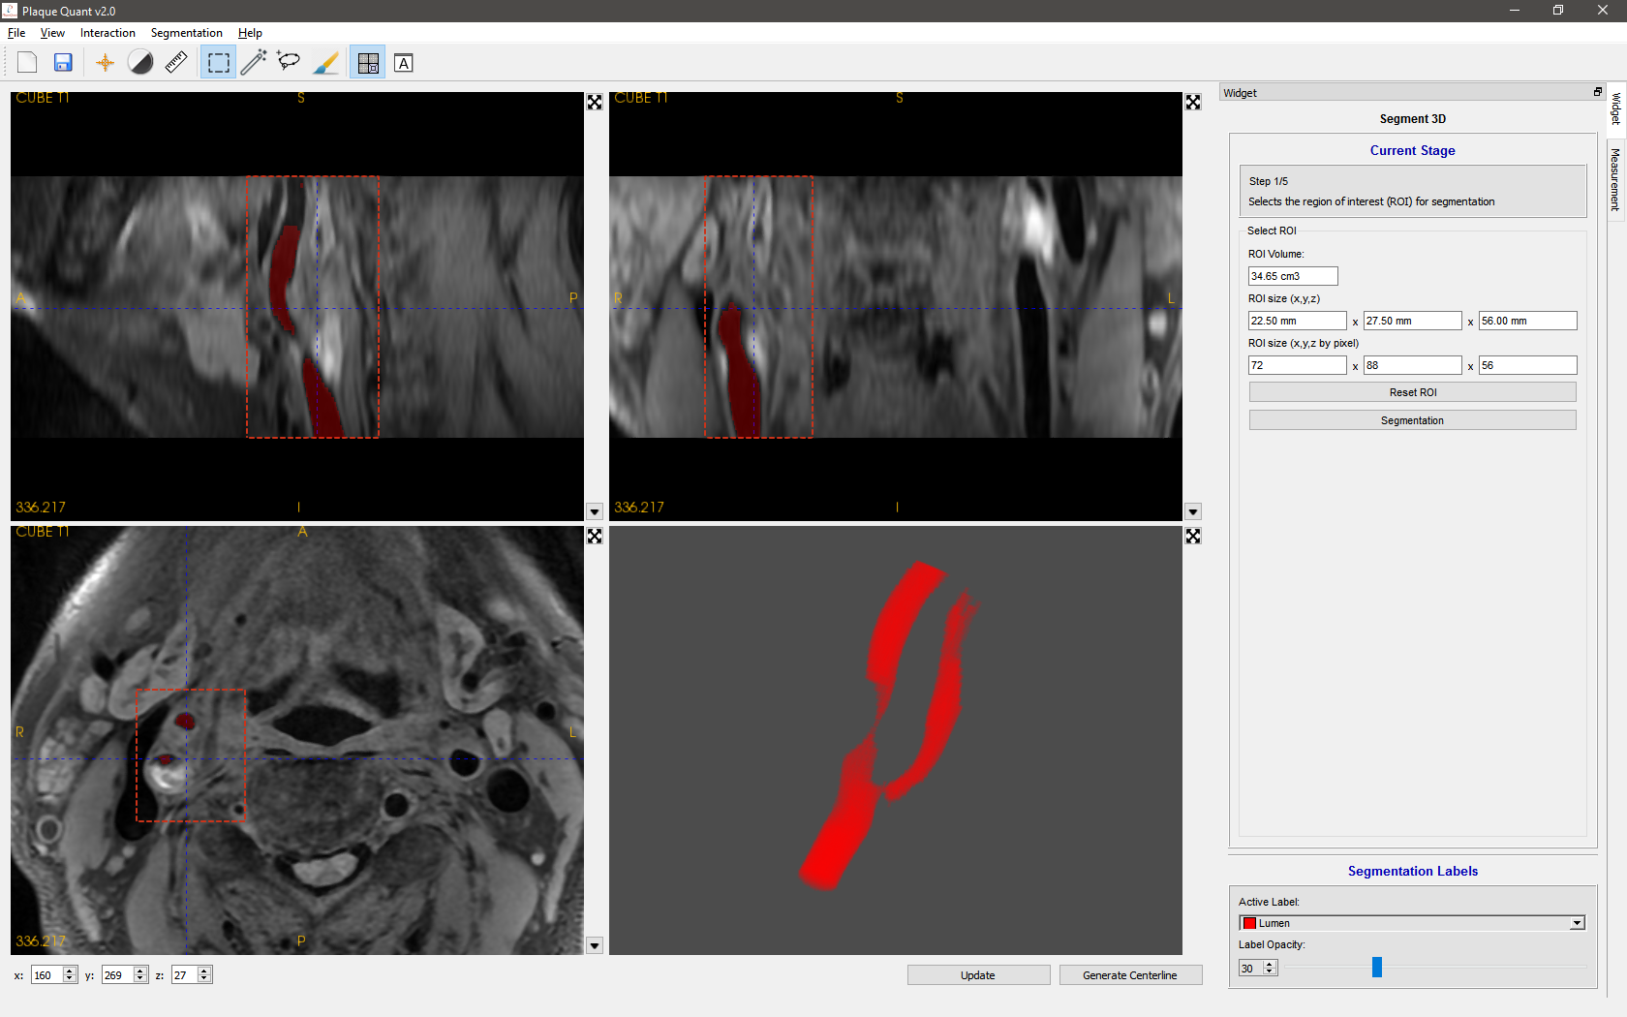

Figure ROI selection

After finishing changing the frame, user can click the button “Segmentation” (Figure 12) to extract the ROI.



Figure RHS Panel

If user is not satisfied, clicking “Reset ROI” will resume the viewer to original space.

**Note that the ROI selection is faulty in Axial view. Please use it in multi-planar view.**

#### Contour Draw

Pressing the button  allows user to switch to “Contour Draw” mode. In this mode, user is supposed to use contour to do the lumen and vessel wall segmentation.

Normally the vessel wall and lumen are easily recognizable in axial view. So user is suggested to only using contour in axial-view 2D viewer or change to axial view of multi-modality. User is also suggested to maximize the working 2D viewer for better performance.

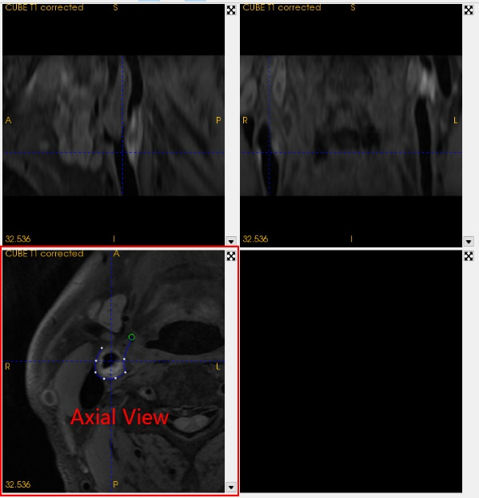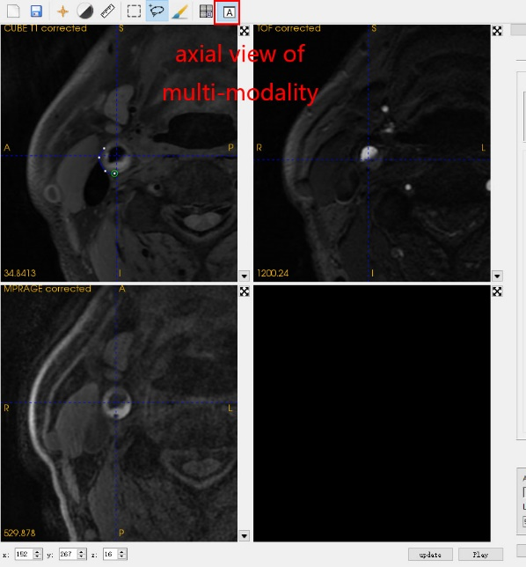

Figure Axial view

This mode also allows semi-automatic segmentation “Auto Lumen Extraction”. To activate this function, check the box labeled “Enable” in Figure 14.

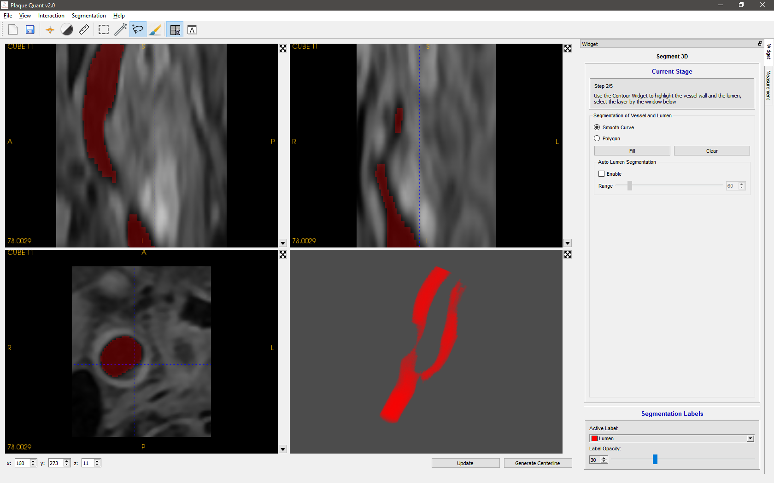

Figure Lumen segmentation

Specify the vessel wall normally, then press right mouse button to preview the lumen contour. Slide the slider labelled “Range” to determine the threshold used to estimate the lumen (Figure 15), which generally has a much lower intensity when compared to the wall.

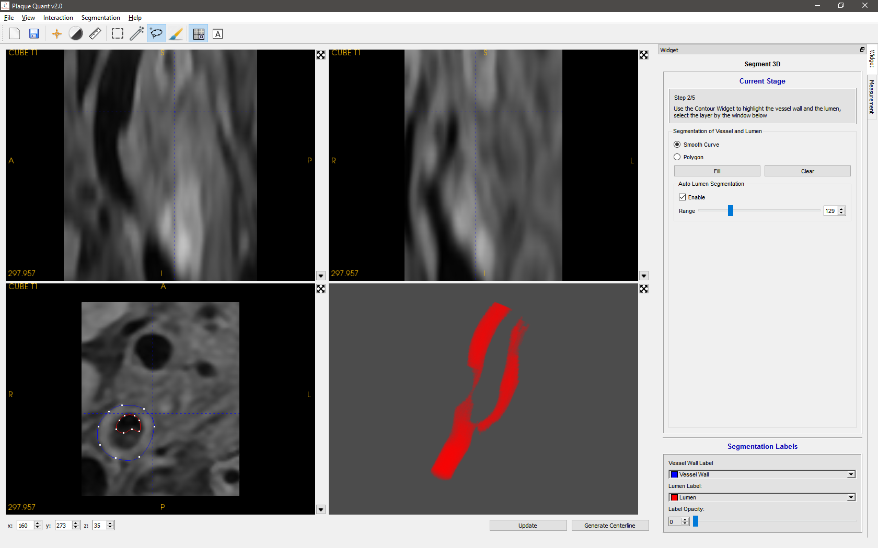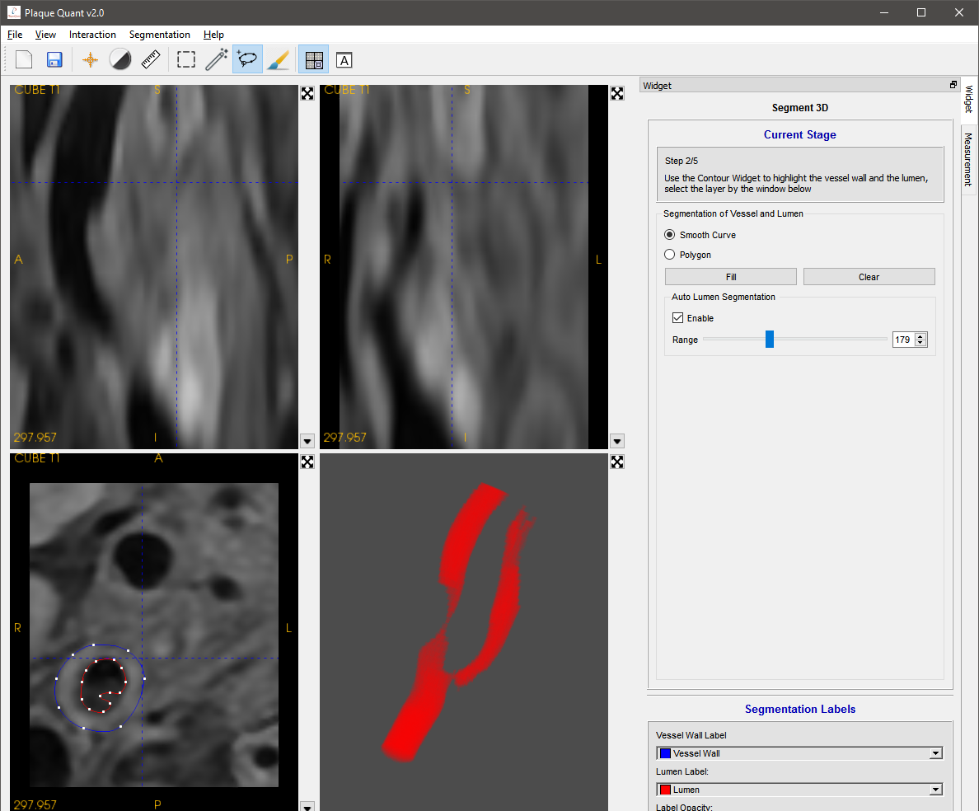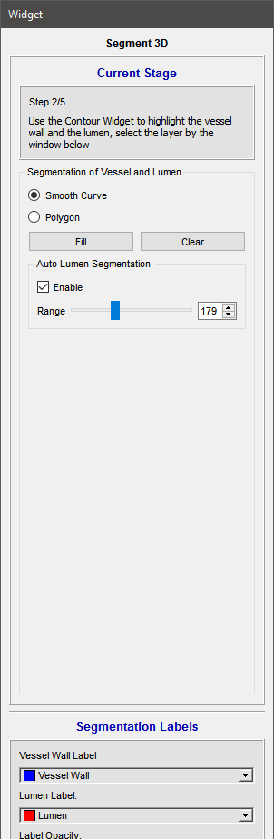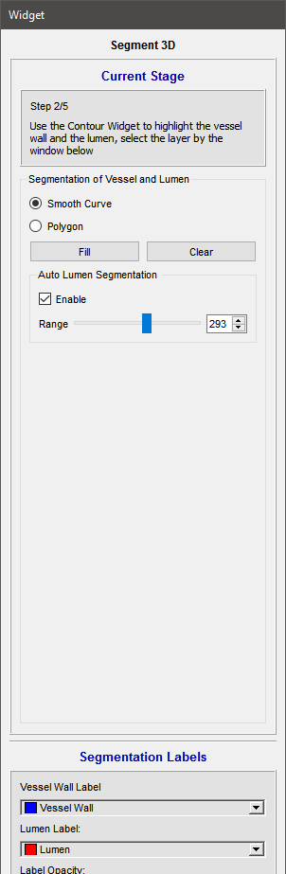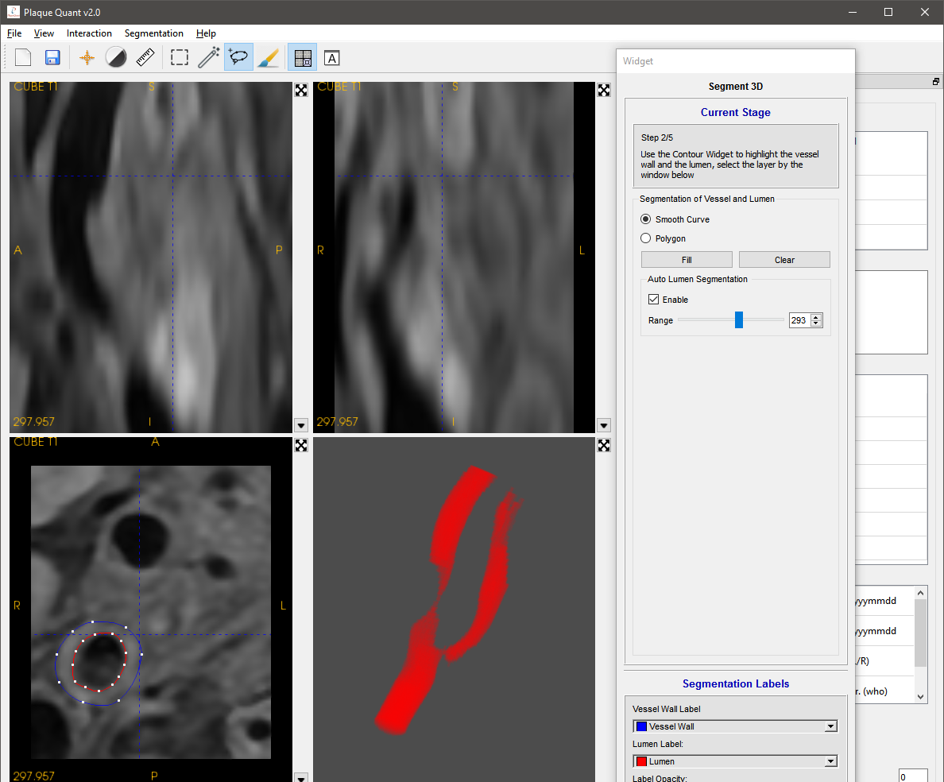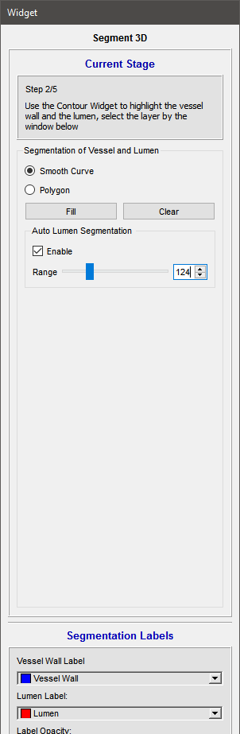

Figure Slider Demonstration

Interactions are tabulated as follow:

|  |  |
| --- | --- |
| **Interaction** | **Action** |
| Enter | Close contour loop |
| Esc | Cancel segmentation |
| Delete | Delete last contour node under mouse |
| L-Mouse Click | Place a contour node under mouse |
| R-Mouse Click | **Before loop closed:**  Close the loop  **Auto Segmentation activated:**  Close the loop and activate lumen location |
| L-Double Click | **After loop closed:**  Draw segmentation with active label |
| L-Long Press | **Before loop closed:**  Continuously place node under mouse  **After loop closed:**  Drag node under mouse |

#### Paint brush

In this mode, user is supposed to use paint brush to optimize their segmentation result.

Paint brush is a quite straight forward widget for user to do segmentation. However, it is too time consuming to do all segmentation manually. Using contour should be the best option. But user can still use paint brush to optimize their segmentation and add other label, such as calcification, hemorrhage.

On the right side is the paint brush configuration. User can change the brush size and brush shape. The lower part is for selecting paint brush label.

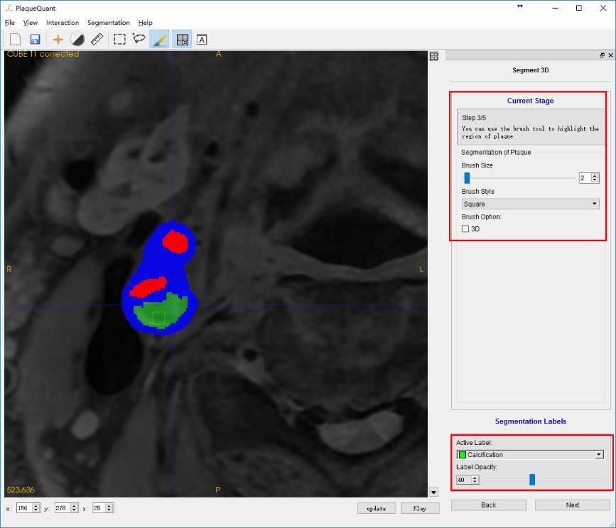

Figure Paint brush

|  |  |
| --- | --- |
| **Interaction** | **Action** |
| L-Long Press | Draw with the active label under cursor. |
| R-Long Press | Erase the label under cursor. |

#### Smart Contour

Press the button  to enter “Smart Contour” mode. This mode is a semi-automatic segmentation mode. The algorithm calculate users input seeds to locate the lumen and dilate the lumen label to give an estimation to the vessel wall.

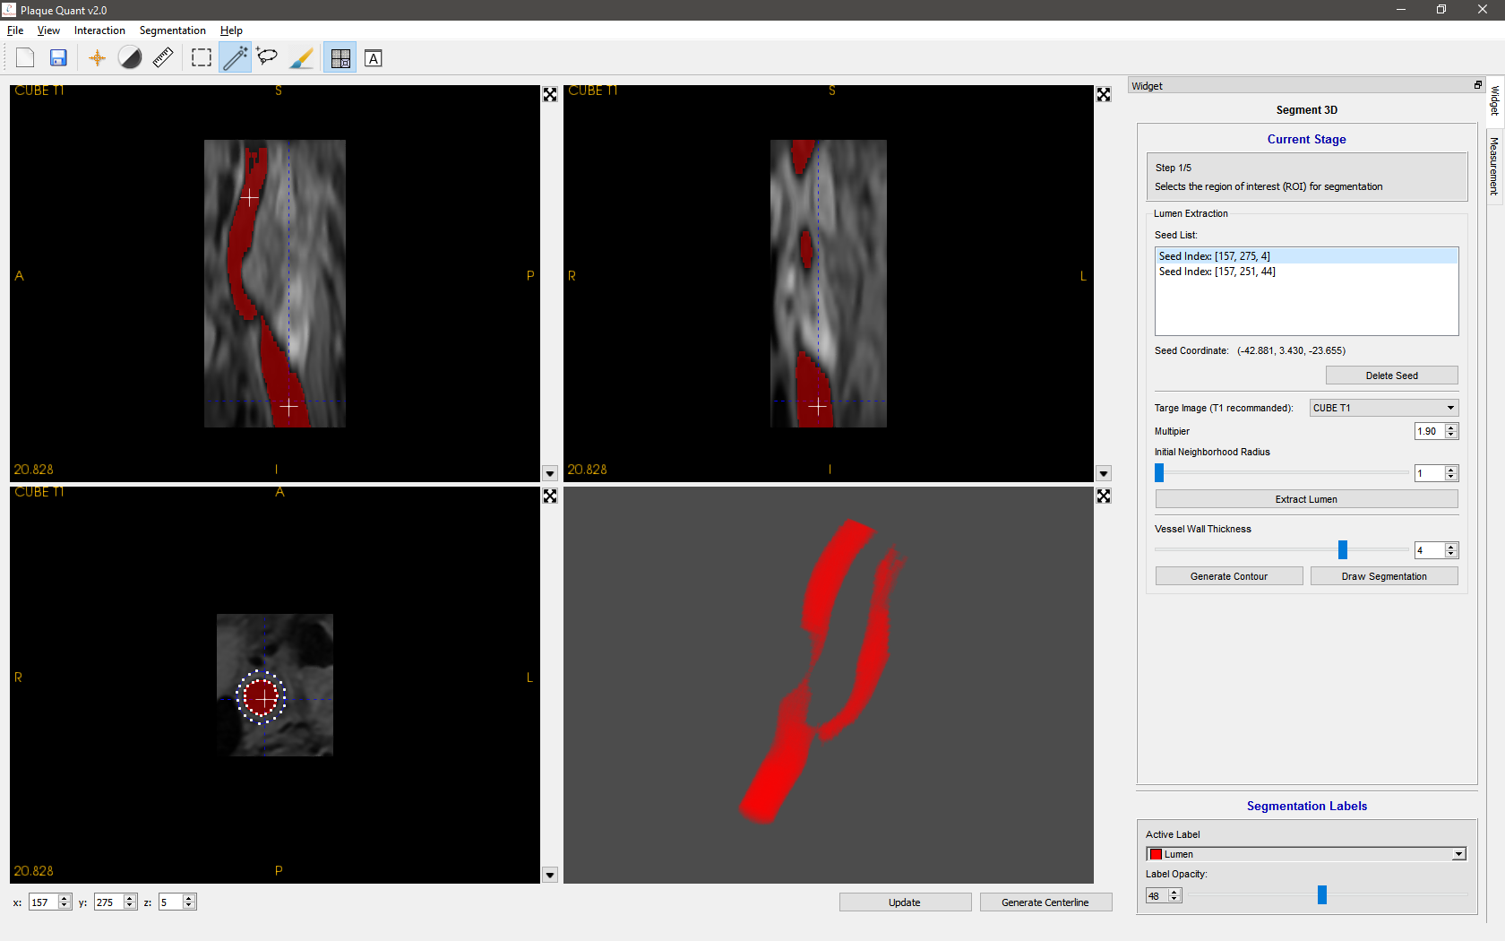

Figure Seeds

Generally, users can take reference to the follow the steps:

1. Place one to three seeds inside lumen as separated as possible (Figure 17).
2. Press “Extract Lumen” to automatically calculate the lumen.
3. If the resultant red label fill the whole viewer, reduce the value of “Multiplier” and retry step 2 until satisfied.
4. If the resultant red label is fills up only small portion of lumen, increase the parameters “Multiplier” and “Initial Neighborhood Radius” and retry step 2 until satisfied.
5. If there are still unsatisfactory holes at the top/bottom of the segmentation, use “Paint Brush” or “Contour Draw” mode to fill them up.
6. Estimate the pixel width of vessel wall and adjust parameter “Vessel Wall Thickness”.
7. Press “Generate Contour”, this process could take around 30s depending on machine.
8. Examine each layer, modify the automatically generated contour if necessary.
9. Press “Draw Segmentation”

To review placed seed, select the seed in the list and the cursor will automatically snap to the selected seed.



Figure Select Seed

To unwanted seeds, select the seed in list and press “Delete Seed” (Figure 19)



Figure Delete Seed

It is recommended to use T1 image for this algorithm, but if users wish to perform this action with other image modality loaded, use the combo box labeled “Target Image”.



Figure Target Image Combo Box

### 2D & 3D Numerical Measurements

After finishing editing segmentation, user can get 2D & 3D numerical measurements from the software. All the measurements can be updated in real time when user changes the current slice.

To view the measurement, click on the “Measurement” tab on the RHS panel.

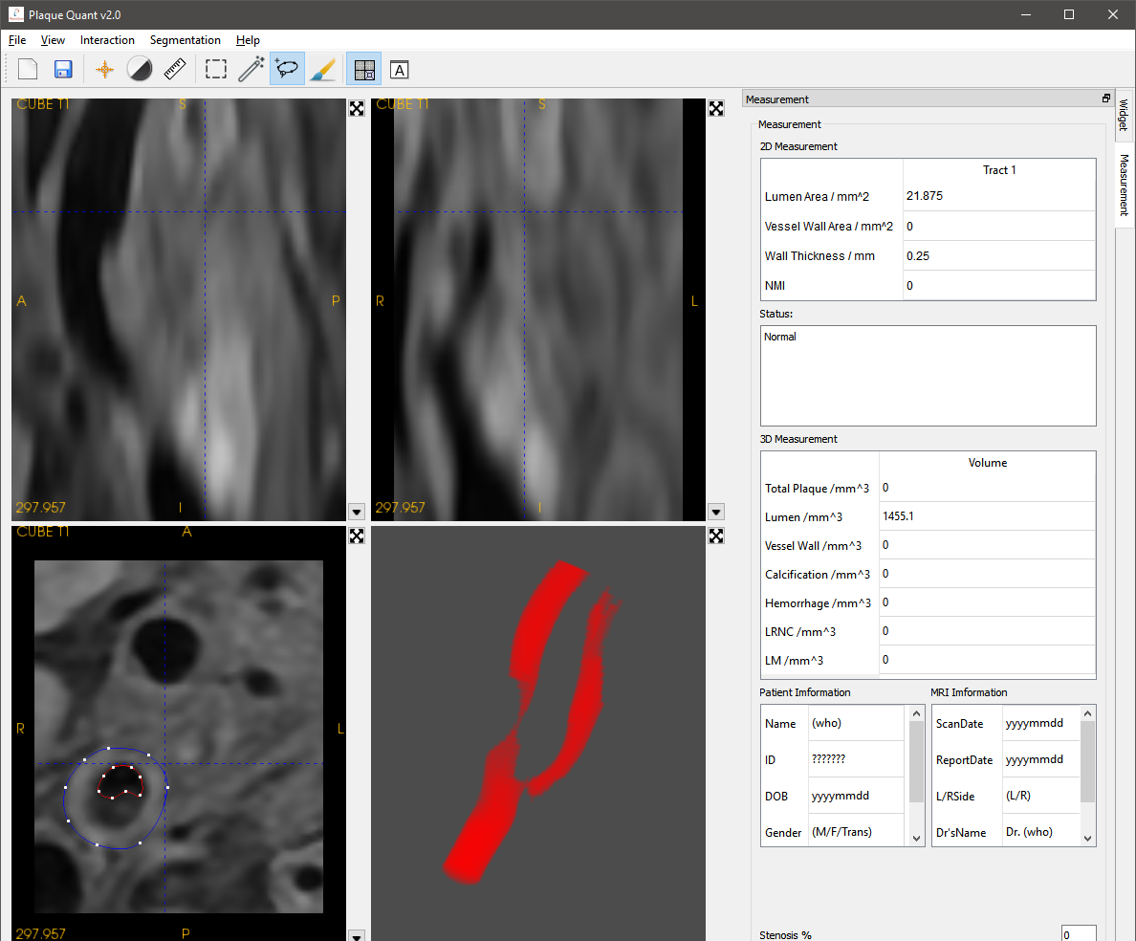

Figure Measurement Tab

#### Maximum Wall Thickness

By clicking “Measurement” of the RHS Panel to move to “Step 4/5”, user can enable the algorithm, maximum wall thickness, which is the maximum distance between the lumen wall and vessel wall.

By setting checked of the “show maximum wall thickness”, the software can automatically find out the maximum wall thickness of the current slice show its trajectory in the 2D viewers. And the status text frame can tell the user whether the software can find the distance.

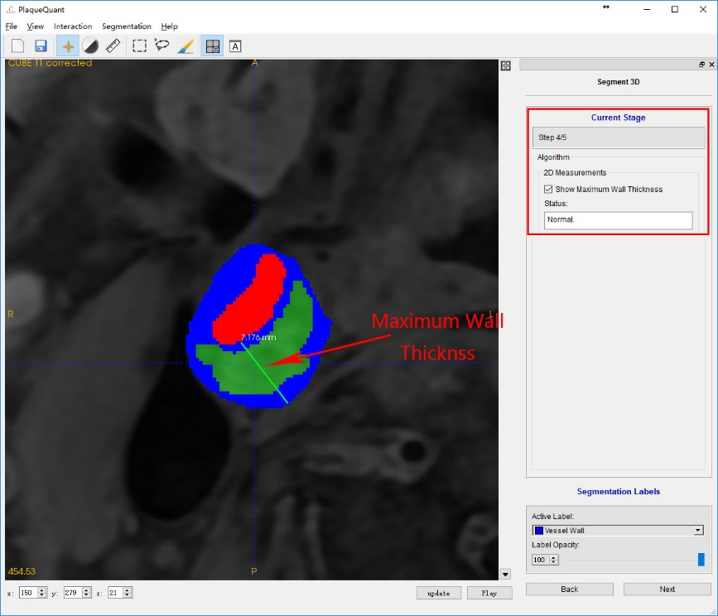

Figure Maximum Wall Thickness

However, because of the ambiguity of vessel segmentation, the algorithm cannot guarantee that maximum wall thickness can always be found and the precision. User should judge the result on their own opinions and use distance mode instead.

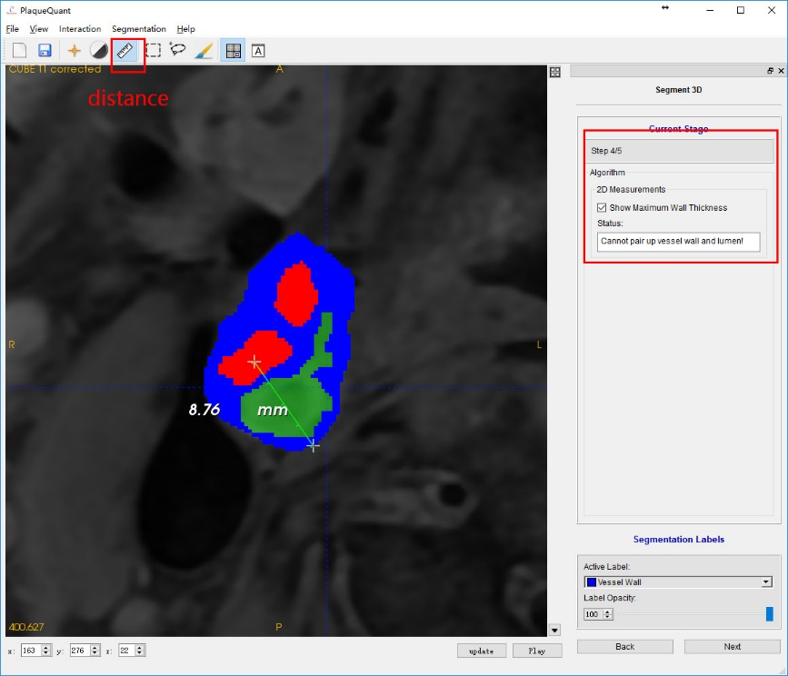

Figure Manual measurements

#### 2D Numerical Measurements

2D numerical measurements provide following straight forward data of current slice:

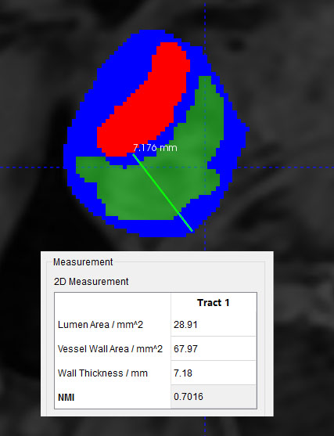

Figure Maximum Wall Thickness

|  |  |
| --- | --- |
| Quantity | Details |
| Lumen area (mm2) | the area of label “lumen” of current slice |
| Vessel wall area (mm2) | the area of label “vessel wall” of current slice |
| Wall thickness (mm) | the maximum distance between the lumen wall and vessel wall |
| Normalized Wall Index (1) | $$\frac{vessel wall area}{vessel wall area+lumen area}$$ |

#### 3D Numerical Measurements

3D numerical measurements provide following straight forward data of the segmentation results:

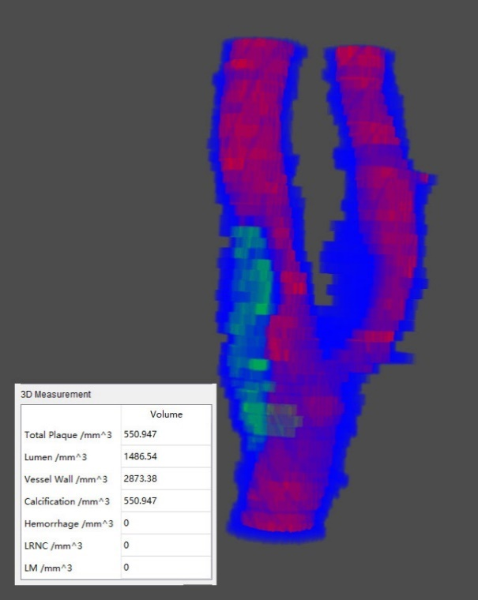

Figure 3D Measurements

|  |  |
| --- | --- |
| Quantity | Details |
| Total plaque (mm3) | calcification + hemorrhage + LRNC + LM |
| Lumen (mm3) | lumen volume |
| Vessel wall | vessel wall volume |
| Calcification | calcification volume |
| Hemorrhage | hemorrhage volume |
| LRNC | LRNC volume |
| LM | LM volume |

#### Stenosis

The software also provides an intuitive quantity named “Normalized Wall Index” (NMI) for user to measure severity of stenosis:

$$NMI=1-\frac{stenosis radius}{reference radius}$$

The user is supposed to use ROI mode to remove redundancy (the bottom part and the top part of the segmentation should be removed). By selecting ROI and click “segmentation” on the segmentation window. Then changing the opacity of every label (such as 5) in case of blocking the sight

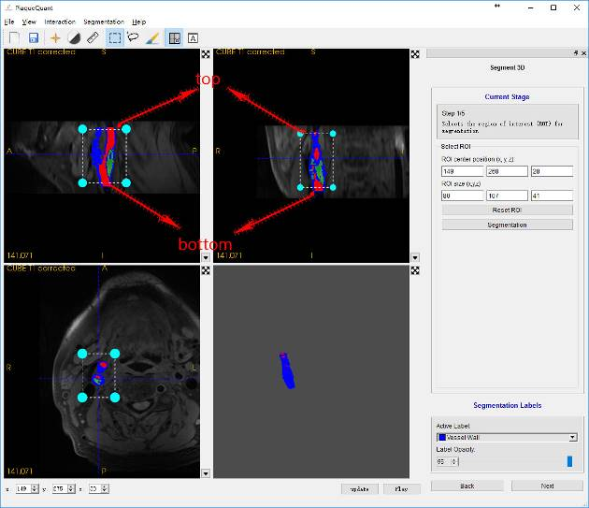

Figure ROI selection

After that user is supposed to click “update” to render their segmentation. This time the center line of the vessel can be seen clearly in the 3D viewer.

User should select 2 points on the center line by pressing keyboard “Enter”, a sphere on the center line will label the selected location and keyboard “Delete” will clear all spheres. User should define their own 2 spheres location. After 2 spheres have been specified, the stenosis will be automatically filled for the user.

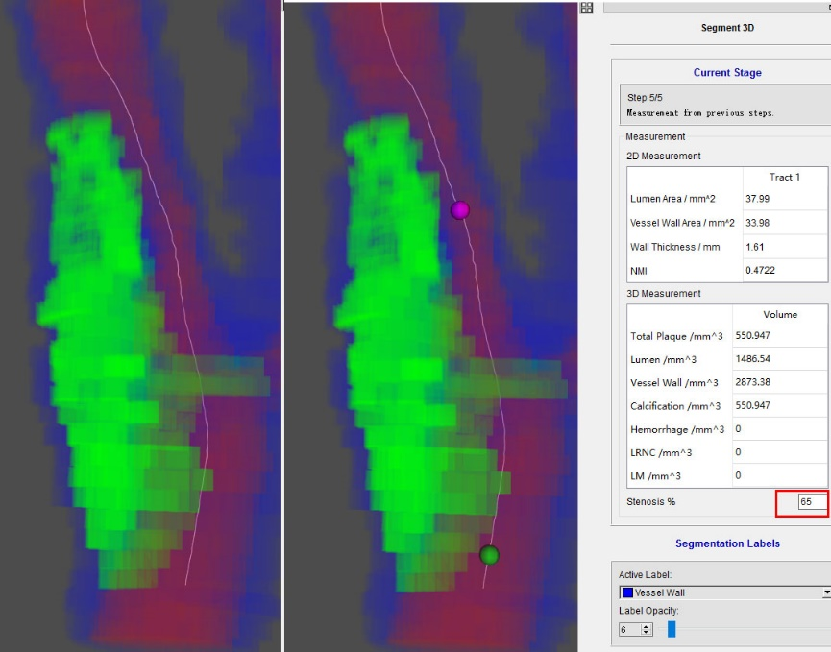

Figure Reference & Stenosis point selection

### Generate Report

After finishing all segmentation, user can generate their own report for their particular images. The report generated by the software have all important data from the segmentation.

The user is supposed to change the slice of lower left 2D viewer and view angle of 3D viewer which they are interested in. The report generator will generate a report which is based on these 2 viewers, the 2D & 3D numerical measurements and information from DICOM images.

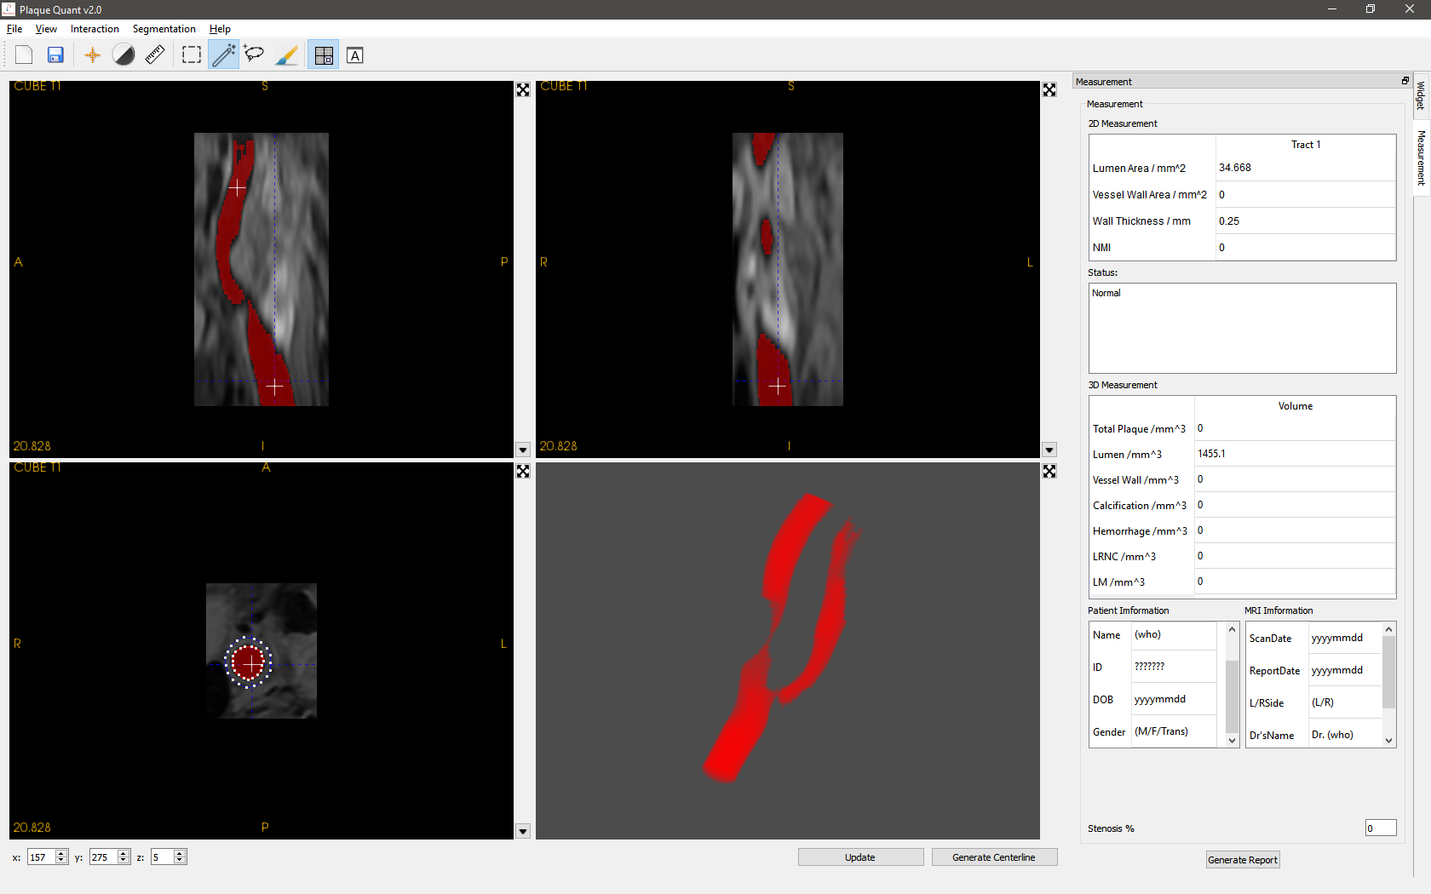

Figure Generate report

### Saving & Opening Segmentation

Users are advice to save their segmentation from time to time since the auto recovery function is yet to be implemented.

User can click “File->save” on the menu bar or “save” on the tool bar to save their segmentation result. The segmentation will be saved in NIFTI format.

User can also open their segmentation again after open their original image, by clicking “segmentation->open segmentation” on the menu bar.

## Known Issues

1. Discontinuous segmentation results in several functions failures.
2. Opacity cannot be updated real time for 3D volume rendering.
3. Centerline extraction might fail if there are outliners, such as miss drawn point outside of the vessel or a hole inside the lumen, in the segmentation.
4. ROI widget behave strangely in Axial view.

## Update Log

Version 2.0 - 10/24/2016

* Add “Smart Contour” segmentation
* Major change to hierarchy
* Major change to UI layout
* Fix crash when segment without ROI **#Issue9**
* Fix crash when ROI cannot cut the inlet and outlet of blood vessel. **#Issue14**
* Fix crash when update 3D label without any drawn label **#Issue12**
* Fix crash when reset ROI before segmentation **#Issue9**
* Fix “Auto Lumen Extract” crash when cannot find lumen during threshold **#Issue7**
* Fix crash when saving segmentation after cropping image **#Issue15**